Why Record Oral History?

Each one of us has changed the course of history. By uprooting ourselves and having the courage to start a new life halfway around the world, we have changed the course of future for our children and grandchildren.

From your story, your descendants will someday learn about you, their ancestor − your real-life struggles, your sacrifices and achievements, and feel grateful and proud.

This is the power of Oral Histories

We have recorded
Stories of:

Zarine Balsara
Mehli Behrana
Peshotan Bhadha
Jerbanoo Bhadha
Feroze Bhandara
Behram Bilimoria
Meherwan Boyce
Sarosh Collector
Nano Daroowala
Homi Davier
Rohintan Deputy
Adi Desai
Thrity Desai
Kaemerz Dotiwala
Rustom Engineer
Homi Erani
Piloo Ilavia
Katie Irani
Zenobia Guzder
Vehishta Kaikobad
Jimmy Kumana
Sarosh Manekshaw
Percy Master
Noshir Medhora
Jehanbux Mehta
Jangoo Mistry
Shapur Pavri
Yasmin Pavri
Meheryar Rivetna
Shaheen Rustom
Aban Rustomji
Vispi Sagar
Hoshang Sethna
Nergesh Sethna
Bapsi Sidhwa
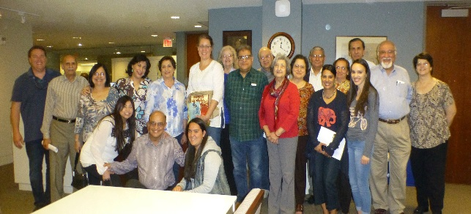

ZAH ORAL HISTORY PROJECT

Tell your Story
Preserve Our History

What is Oral History?

Oral history is the first hand recounting of memories by living people about events or social conditions which they experienced in their earlier life, recorded and preserved as historical evidence.
There are innumerable oral history projects all over the world that have been undertaken whenever there is a need to preserve something valuable before memories fade and life stories are lost forever.
As a first-generation Zoroastrian diaspora in the U.S., uprooted and settled into a vastly different culture, the stories of our lives are worth capturing.

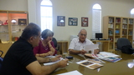

What ZAH has done

In 2014, the Library Committee of the Zoroastrian Association of Houston (ZAH) launched the ambitious Oral History Project that has been recording and preserving the rich backgrounds and experiences of our fellow Zoroastrians in Houston.

A little over 30 seniors were interviewed, who shared their life experiences and recollections of their lives dating back to early years in their homeland, and as immigrants to the U.S.

Every interview has been recorded and catalogued into the new digital Zoroastrian Archive at Rice University in Houston. This means that anyone, anywhere in the world, can now access these Zoroastrian oral histories either as an audio recording or as a written transcript.

A Google search on “Zoroastrian Community Interviews” brings up the entire list of people interviewed and you can click on any name to hear or read the recorded interview.

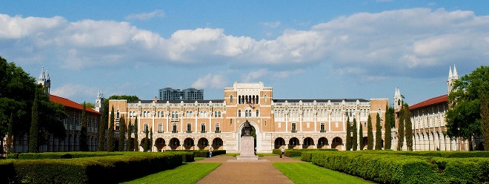
What you need
to do

We welcome other FEZANA Associations to join us in this pioneering effort. Encourage your members to document their lives for posterity.

In a nutshell, you will need:

- Volunteers to tell their life stories
- Volunteers to interview and record the stories
- A secure location to store the audio and text transcripts digitally

We are ready and willing to share our learning experience with any organization that is interested in undertaking this important project. Just contact Aban Rustomji (aban@coatingindustries.com) for help and guidance

